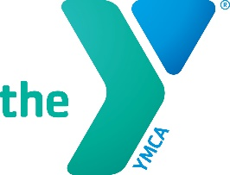

DARIEN YMCA YOUTH SAILING PROGRAM 2019
Beginner sailing lessons offered on Holly Pond to children ages 7 – 12 years
Darien YMCA experienced sailing staff will provide instruction on using catamarans and sunfish sailboats
Instruction will include: basic boating safety, the parts of the sailboat, how to rig and de-rig a sailboat, how to safely capsize and right a sailboat and basic sailing rules out on the water.

Program dates:
Monday and Wednesday 6:15pm-7:30 pm
Session 1: 7/1, 7/3, 7/8, 7/10, 7/15, 7/17
Cost: members $195 non $250

