DATE | TIME | Coach |  | DATE | TIME | COACH
Wednesday, June 5th | 10:30-11:30am | Jess |  | Saturday, June 22nd | 1:00-2:00pm | Bea
Saturday, June 8th | 1:00-2:00pm | Bea |  | Tuesday, June 25th | 9:30-10:30am | Nicole
Tuesday, June 11th | 9:30-10:30am | Nicole |  | Friday, July 5th | 12:30-1:30pm | Nicole
Wednesday, June 12th | 4:00-5:00pm | Beverly |  | Friday, July 12th | 12:30-1:30pm | Nicole
Tuesday, June 18th | 9:30-10:30pm | Nicole |  | Friday, July 19th | 12:30-1:30pm | Nicole
Wednesday, June 19th | 4:00-5:00pm | Beverly
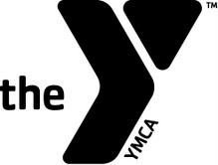
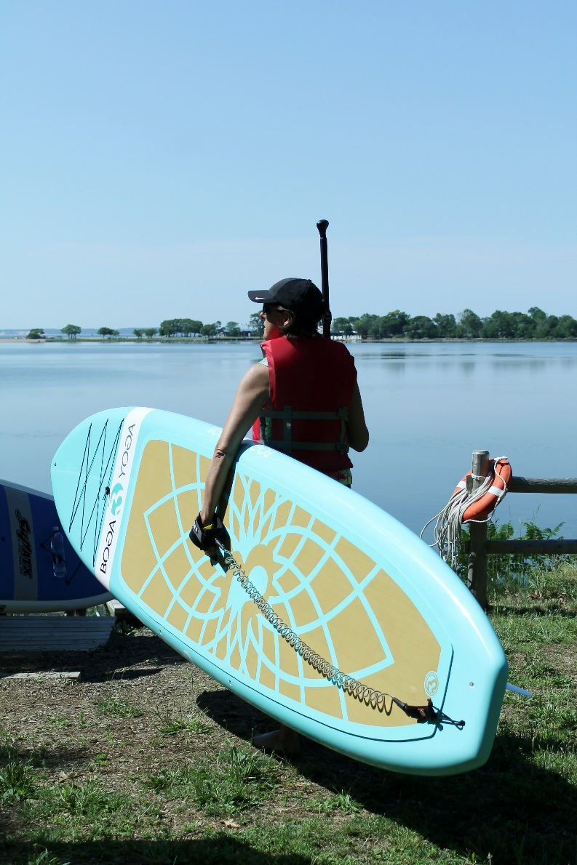
JUNE/JULY 2019
SCHEDULE!
Can’t find a SUP class that works for you and a Friend? Reach out to our Health & Fitness Director, Jess, at Jvansciver@darien-ymca.org to set up a session!
PaddleFit Intro Class
Time: 1 hour
Age: 15 and up
Fee: Members/$30; Non-Members/$40

Your instructor for PaddleFit Intro will greet you in the Front Lobby. Please make sure to arrive 10-15 minutes prior to your class start time. This will allow for time to store any personal items, change into appropriate clothing and to sign our waiver.

The Darien YMCA is pleased to announce the launch of our 2019 SUP (Stand Up Paddleboard) Season!

The PaddleFit Intro class will introduce you to the sport of Stand Up Paddling (SUP). Our coaches will teach you the fundamentals of SUP in a fun and safe environment. PaddleFit Intro will help you build the foundation for your future paddling endeavors. You will need to be comfortable in the water as well as be able to swim. You do not need to have prior paddling experience to take this class.

Sign up online or at the Front Desk to reserve a spot in one of our PaddleFit Intro classes below:

