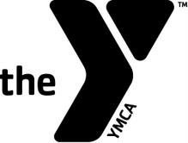
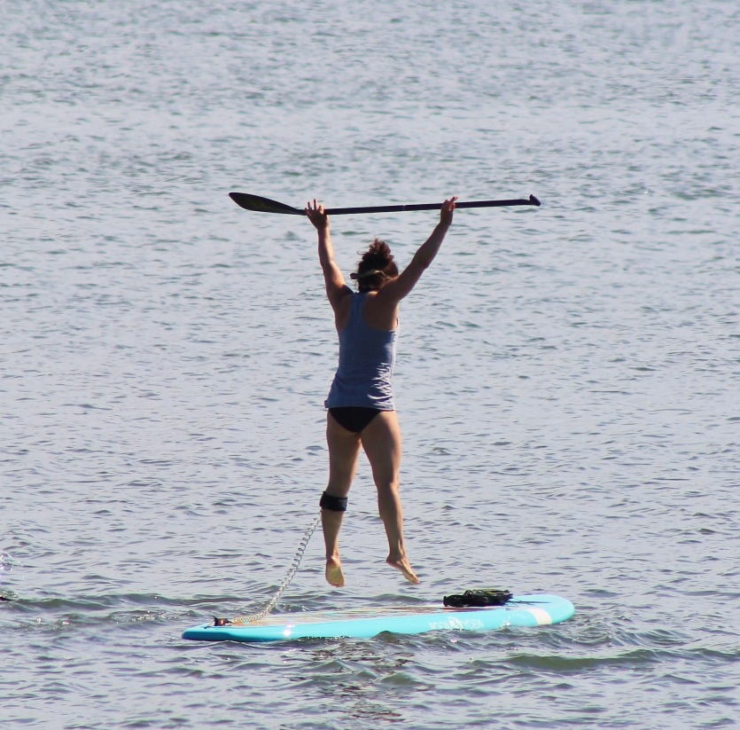
SUP FITNESS
Time: 1 hour
Age: 15 and up
Fee: Members/$35; Non-Members/$45

Your instructor for SUP FITNESS will greet you in the Front Lobby. Please make sure to arrive 10-15 minutes prior to your class start time. This will allow for time to store any personal items, change into appropriate clothing and to sign our waiver.

JUNE/JULY 2019
SCHEDULE!

Here is your chance to get introduced to the world of PaddleFit and its training program
through our fun and challenging introductory fitness class. We will give you a taste of
the many benefits of training on the water that include: board skills, balance, endurance, strength and focus. Now is the time to start on your path to get on the water and achieve your training goals. This class is designed to accommodate all skill levels but participants must have prior SUP experience.

Private SUP FITNESS is available by appointment as well. Please reach out to Jvansciver@darien-ymca.org for details and questions.

SUP FITNESS
AT THE DARIEN Y

DATE | TIME | COACH |  | DATE | TIME | COACH
Wednesday, June 12th | 10:30-11:30am | Jess |  | Tuesday, July 9th | 9:30-10:30am | Nicole
Saturday, June 15th | 10:00am-11:00am | Beverly |  | Wednesday, July 10th | 10:30-9:30am | Jess
Wednesday, June 19th | 10:30-11:30am | Jess |  | Tuesday, July 16th | 9:30-10:30am | Nicole
Wednesday, June 26th | 10:30-11:30am | Jess |  | Wednesday, July 17th | 10:30-11:30am | Jess
Saturday, June 29th | 10:30-11:30am | Bea |  | Tuesday, July 23rd | 9:30-10:30am | Nicole
Wednesday, June 19th | 10:30-11:30am | Jess |  | Wednesday, July 24th | 10:30-11:30am | Jess
Wednesday, June 26th | 4:00-5:00pm | Beverly |  | Tuesday, July 30th | 9:30-10:30am | Nicole
Tuesday, July 2nd | 9:30-10:30am | Nicole |  | Wednesday, July 31st | 10:30-11:30am | Jess
 |  |  |  | Tuesday, July 9th | 9:30-10:30am | Nicole
Sign up at the Front Desk to reserve a spot in one of our SUP FITNESS classes.
PaddleFit Intro is REQUIRED before taking SUP FITNESS, as this is not a lesson. Please visit our website for the latest PaddleFit Intro classes and details.
*Please note there is no online registration for this class*

Can’t find a SUP class that works for you and a Friend? Reach out to our Health & Fitness Director, Jess, at Jvansciver@darien-ymca.org to set up a session!

