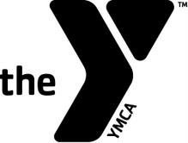
SUP YOGA
AT THE DARIEN Y

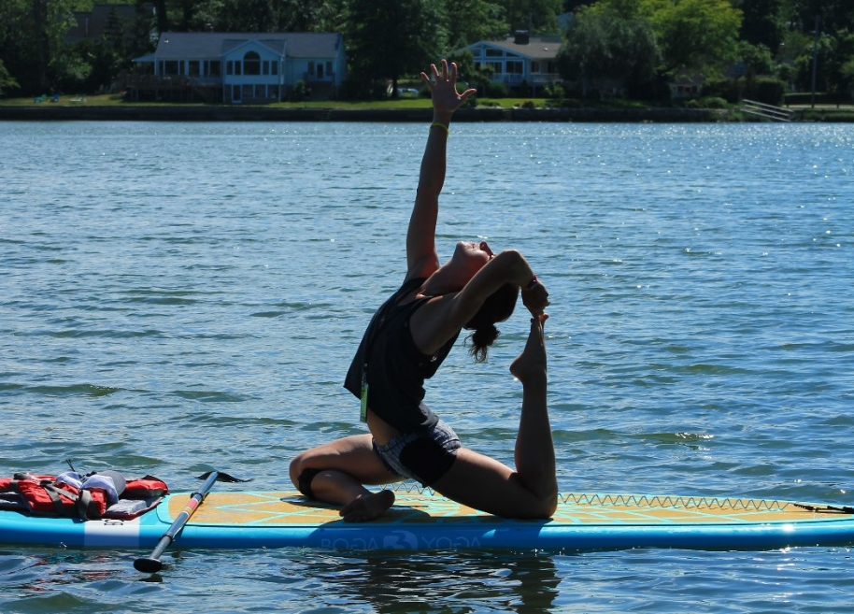
JUNE/JULY 2019
SCHEDULE!
SUP YOGA will reinvigorate you and push you to become an even better yogi than you thought possible—all while enjoying the natural splendor of floating on water. Take a course here at the Darien Y and see why this amazing class might be your new obsession.
IT’S FUN.
IT’S CALMING.
IT’S BEAUTIFUL.
IT’S EMPOWERING.
IT’S CHALLENGING.
IT TEACHES YOU TO GET BACK UP.
IT HELPS YOU FOCUS ON YOUR BREATH.
IT WILL REFINE YOUR YOGA TECHNIQUE.

Private SUP YOGA is available by appointment as well. Please reach out to Jvansciver@darien-ymca.org for details and questions.

SUP YOGA CLASS
Time: 1 hour and 15 min–paddle to/from location and Yoga class.
Age: 15 and up
Fee: Members/$35; Non-Members/$45

Sign up online or at the Front Desk to reserve a spot in one of our SUP YOGA classes.
Some SUP experience is necessary, as this is not a lesson. Please visit our website for the latest PaddleFit Intro classes for details.

Tuesdays from 11am-12:15pm with Talita
(No 11am class held on 7/2 and 7/9)

Tuesdays SUNSET SUP YOGA from 7pm-8:15pm with Danielle

Your instructor for SUP YOGA will greet you in the Front Lobby. Please make sure to arrive 10-15 minutes prior to your class start time. This will allow for time to store any personal items, change into appropriate clothing and to sign our waiver.

