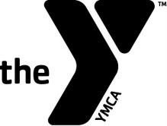
SUP YOUTH!
AT THE DARIEN Y

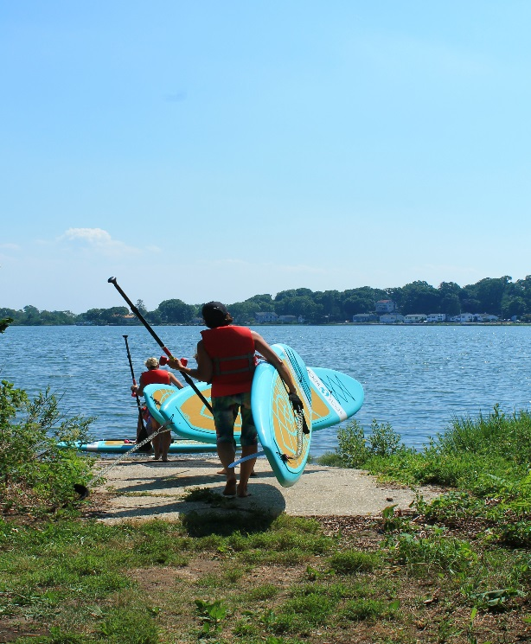
SUP YOUTH will be your kids’ favorite after school activity this SUMMER!
Classes Taught by:

Talita Moss, Darien Y’s Teen Yoga, SUP, Outdoor and Land Yoga instructor
Talita will teach participants how to have fun, balance and focus by incorporating SUP YOGA and PaddleFIT Coaching excursions out on Holly Pond. Sign your kid up (ages 11-14) and see why this amazing class might be their new obsession!
IT’S FUN.
IT’S CALMING.
IT’S BEAUTIFUL.
IT’S EMPOWERING.
IT’S CHALLENGING.
IT TEACHES YOU TO GET BACK UP.
IT HELPS YOU FOCUS ON YOUR BREATH.
IT WILL REFINE YOUR TECHNIQUE.

Private SUP YOGA is available by appointment as well. Please reach out to Jvansciver@darien-ymca.org for details and questions.

SUP YOUTH CLASS
Time: 1 hour and 15 min–paddle to/from location and Yoga class.
Age: 11-14 years old
Fees:
Members: $35 per class
Non-Members: $45 per class

Your instructor for SUP YOUTH instructor will greet you in the Front Lobby. Please make sure to arrive 10-15 minutes prior to your class start time. This will allow for time to store any personal items, change into appropriate clothing and to sign our waiver.

Sign up online or at the Front Desk to reserve a spot in each
SUP YOUTH class.
NO SUP experience is necessary.

Date | Time | Coach
Thursday, June 20th | 3:00-4:00pm | Lisa
Thursday, June 27th | 3:00-4:00pm | Lisa
Thursday, July 11th | 3:00-4:00pm | Lisa
Thursday, July 18th | 3:00-4:00pm | Lisa

